Qingdao University
Bachelor of Software Engineering for International Students

Qingdao University
Qingdao University is situated in the eastern coastal city of Qingdao, which is a famous tourist destination and leisure city of China. It was founded in 1909 and now is one of the key universities in China. In 1993, Qingdao University became even more versatile when it was merged with three other major universities. It has a wide range of disciplines and is accredited to grant Bachelor’s, Master’s, and Doctorate degrees.
As one of the 50 Universities approved the qualification of enrolling international students by Ministry of Education, Qingdao University started enrollment of international students from 1987. Qingdao University was approved as HSK test center by Confucius Institute Headquarters (Hanban) in 1997. QU was authorized as The Demonstration Education Base of Study in China by MOE in 2014 and was authorized as one of 27 universities which is in conformity with the International students Education standard in China. In 2016, over 1600 international students from 61 countries come to study at Qingdao University.

School of Data Science and Software Engineering (SDSSE)
School of Data Science and Software Engineering is one of the 34 schools of Qingdao University. The school has four departments, one teaching experimental training center and one students' innovative entrepreneurship center. There are 7 research centers in the school including the Software Engineering Research Center, the Mobile Internet and Software Technology Research Center, the Internet Education Research Center, the Intelligent Image and Information Processing Research Center, the Digital Science and Big Data Technology Research Center, the Intelligent Systems and Control Technology Research Center, and GIS Software Research and Development Center. There are 75 full time teaching staff among which 5 are professors, 25 are associate professors. 30 of them are PhDs, 42 have master’s degree. There are more than 3900 full-time students, including 3857 undergraduates and 90 graduate students. The school has three undergraduate programs, Software Engineering, Digital Media Technology, and Intelligent Science and Technology, among which, Software Engineering was selected as the program of “Outstanding Engineers Training Plan” by China’s Ministry of Education. The Software Engineering is approved to the key construction discipline of high level application disciplines in Shandong Province.
The school has established a comprehensive cooperation with many famous IT companies such as Oracle, Tencent, and China Mobile Company in joint research and development, campus scientific competitions, internships, recruitments and technical services etc. The school attaches great importance to comprehensively improving the overall quality of students, encouraging students to attend interdisciplinary elective courses, lectures, academic competitions, and team cooperation training courses, to enhance students' communication skills, presentation skills, negotiation skills and team spirit.

Courses Offered at SDSSE

- Core Courses for Software Engineering
*Calculus *Linear algebra *Probability and statistics *Discrete mathematics *Computer composition principle *Program design
*Data structure *Object-oriented analysis & design *Operating system *Algorithm analysis *Database system *Computer network *Demand analysis *Software testing *Software engineering introduction *Software platform *Software architecture *Software project management *Mobile computing *Big data processing *Embedded system *Data mining *Multimedia technology *Artificial intelligence *Virtual reality *Network game design *Parallel computing.
- Chinese Related Courses
*Chinese Integrated * Chinese Culture

Application Information
Application Period: April 1st to June 1st every year
Application Documents:
- Qingdao University application form for international degree-seeking students
- Diploma from high-school or college
- Transcript of high-school or college（The average scores should be higher than 70% and every subject should be higher than 60%.）
- Copy of passport
- Resume (personal and family conditions, study and work experience)
- Guarantee Statement FOR studying program at Qingdao University
*All documents mentioned above should be written in Chinese or English and should be an original or notarized copy.

Living Environment
Students are expected to live in the International Students Dormitory, where single and double rooms are available. Every room is equipped with central heating facilities. Rooms have private shower baths and toilets; all rooms are installed with air-conditioners. Shared kitchens and washing machines are also accessible to students in the dormitory.
The University campuses enjoy tranquil and convenient surroundings. All kinds of daily necessities are available in off-campus supermarkets at low prices. Post offices and banks are near the main gate of each campus. City bus routes connect all campuses with the downtown area, scenic spots, and the train station.

Fee Structure
Items for Payment | Fees
Application Fee | ¥400
Tuition Fee | ¥20,000 per year
Accommodation Fee | ¥11000 – ¥13000 per year (Double room)
Accommodation Deposit | ¥800 per year
Insurance Fee | ¥800 per year
Residence permit Fee | ¥800 per year
Note:
- This fee structure will be used from the beginning of study until graduation.
- All the fees should be paid in Chinese currency (RMB)
- The tuition fee and all other fees must be paid in cash.
- There can be no refunds available (for fees of any kind) if requested for personal reasons during the period of study at our university.

Scholarship
Qingdao Government Scholarship can be applied for this program. Qingdao Government provides full coverage tuition fee for the first year. Qingdao Government Scholarship application form is needed extra.
Quota for Scholarship: 18 persons

Contact
International Students Office Sophia, Wang
Qingdao University Tel: (86) 532-85953863
E-mail: wangfang@qdu.edu.cn
Web: www.qdu.edu.cn

School of Data Science and Software Engineering Amy, Li
Qingdao University Tel: (86) 532-85953366
308 Ningxia Road, Qingdao 266071,China E-mail：lixiaojun@qdu.edu.cn

后请附学院教学、实习等精彩照片及照片简介：
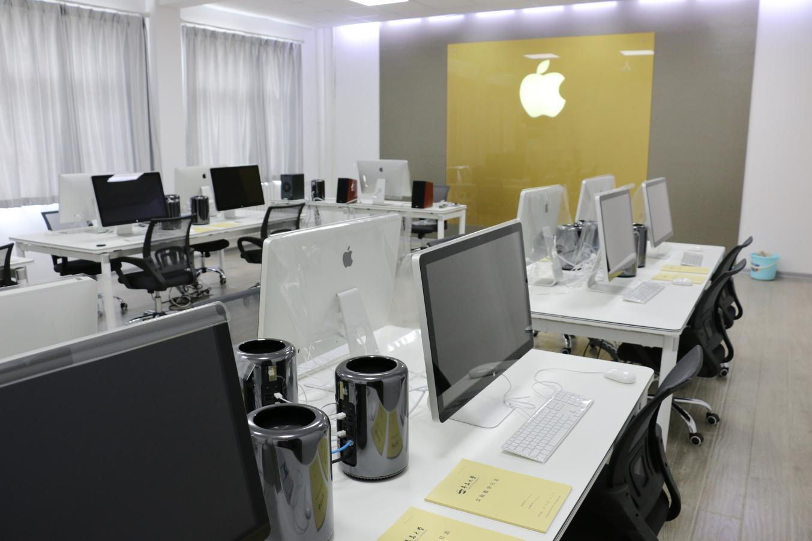
Apple Lab
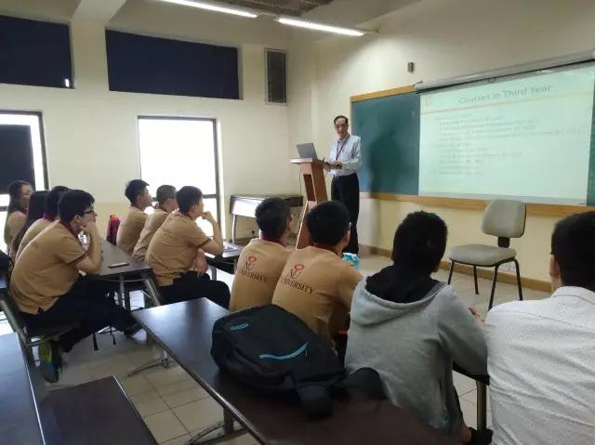
Academic lecture

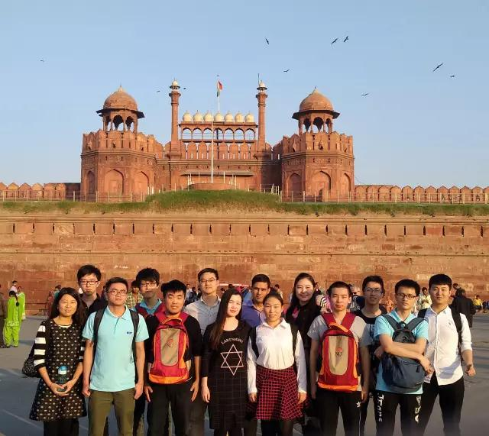

Internship in India

